**Milestone 1 Report**

We drop row that have null value for model1

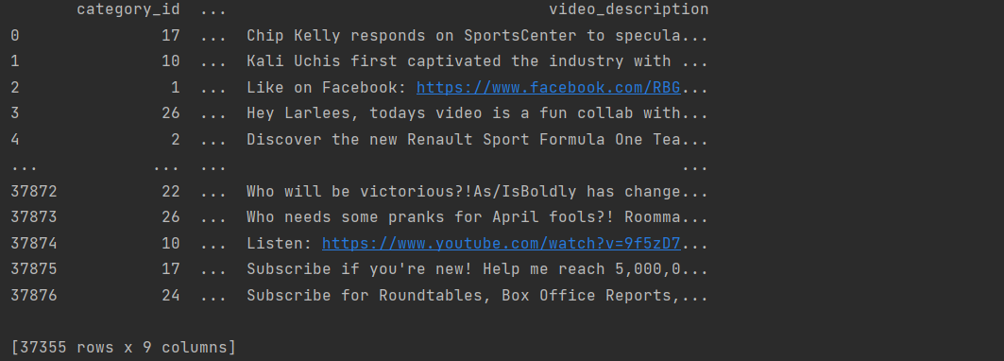

We drop row that have null value for model2

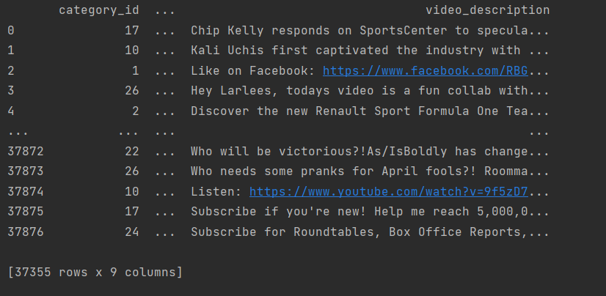

We encode some columns in model1 and model2

cols=('publish_time','tags','comments_disabled','ratings_disabled','video_error_or_removed','video_description')

Correlation for model 1

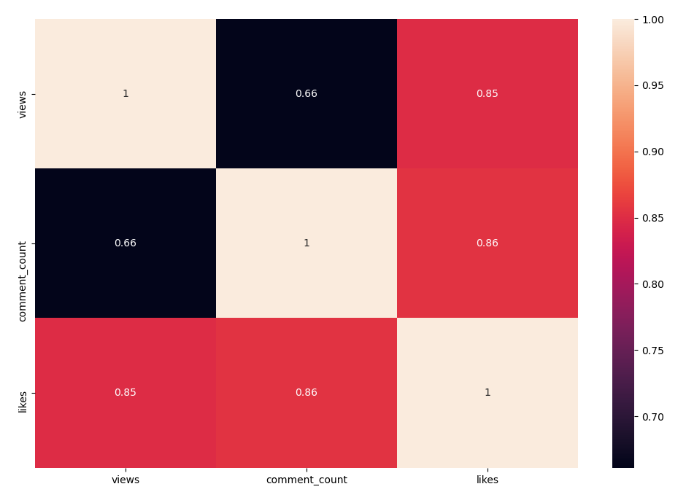

Mean Square Error for model 1 = 5544080776.8917885

Correlation for model 2

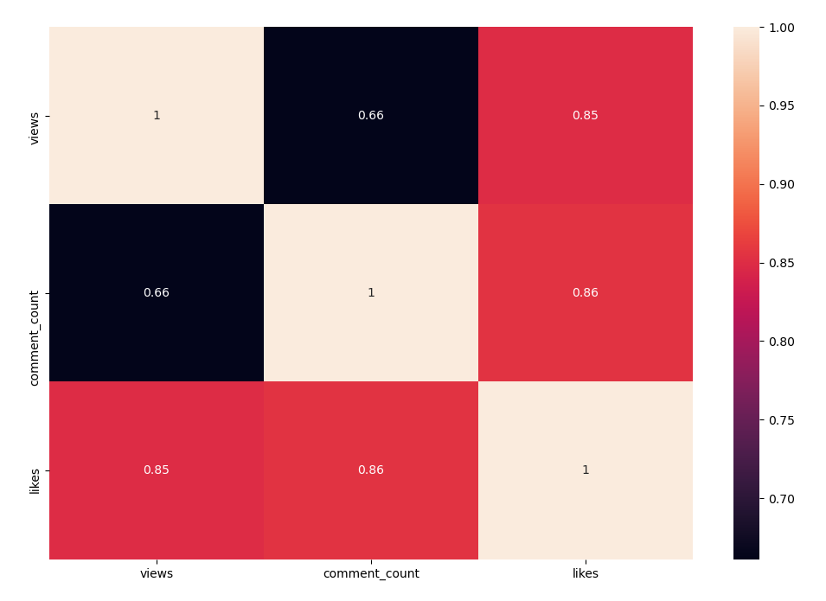

Mean Square Error for model 2 = 3990022008.690075